***On my honor, I pledge that I have not violated the provisions of the NJIT Student Honor Code***

STUDENT TEAM No__**2**__

Name Signature

…Arsh Bhamla………… ___**ARSH BHAMLA~~___~~**_ …Pranay KC………….. _**_PRANAY RAJ KC_____** ..Shreedhar Rajendran. **__Shreedhar Rajendran—**

..Christopher Karkenny. __**Christopher Karkenny**_

Experiment performed on date _03/14/2025__

Report submitted on date ____03/28/2025_____

Returned for corrections on date _________ Grade ______

Returned after corrections on date _________ Grade ______

**Introduction**

In this lab, our group will be gaining experience with the waveform generator, digital voltmeter, analog voltmeter, analog oscilloscope, and digital oscilloscope. We will begin by configuring the DC power supply to produce dual polarity outputs such as +15V and -15V which are standard requirements for circuits like operational amplifiers. We will use the DMV to provide the precise numerical readings, while the AVM will display the voltage variations on a continuous scale, enabling observation of trends. We will then utilize the analog oscilloscope to observe real-time signals produced by the waveform generator and adjust the triggering controls to stabilize the waveform on the display and switch between AC and DC input modes. We will repeat the period and amplitude measurements for the same waveforms with the digital oscilloscope and compare the results with the analog oscilloscope. The DVM and AVM will evaluate each instrument’s performance across various signal frequencies and types to determine their use in circuit analysis.

**Procedure**

**4.1.1 Familiarize yourself with the instruments at your bench**

The goal here is to learn how to use a DC power supply, digital voltmeter (DVM), and analog voltmeter (AVM) to measure and compare voltages. We will start by finding these gadgets on the workbench by powering up the DC supply and set it to 5 volts and then hooking up the DVM to the power supply terminals making sure it is set it to measure DC voltage and the range is correct, and note down what it shows. Next, we will unplug the DVM and connect the AVM to the same spots. We will also set it up right and jot down that reading too like before. We will then compare the results from the DVM, AVM, and the power supply’s built-in display and do this again for 1.5V, 14V, and 30V. We will watch how the readings change and note any differences between the instruments, especially considering accuracy and range settings.

**4.1.2 Configure the power supply**

The goal is to get the DC power supply to output both positive and negative voltages and check it’s working right along the way. We will first check the power supply manual to find the right terminals and settings for dual polarity output and then set the power supply to give + 15V and - 15V with a common ground. We will then use the DVM to measure and note the voltage between the ground terminal and the positive terminal, and also between the ground terminal and the negative terminal along with the voltage directly between the positive and negative terminals. We will make sure the readings match a dual polarity setup and note any differences from what was expected.

**4.2.1 Time measurements**

To measure time, we will connect the waveform generator to the oscilloscope and grounded properly and then set the generator to create a sine wave between 50-500 Hz, and then adjust the oscilloscope’s time base to show at least 3 full cycles. We will measure the period of one cycle and figure out the frequency and see how the accuracy changes. We will examine further by altering the trigger level to stabilize the waveform and seeing its effect.

**4.2.2 Voltage measurements**

We will set the waveform generator to a few hundred hertz and connect the oscilloscope and DVM to the output and adjust the oscilloscope’s vertical scale and note the peak to peak amplitude and DVM’s RMS voltage. We will do the same with triangle and square waves while keeping the settings the same and notice the differences between the data.

**4.2.3 Scope AC and DC inputs**

We will set the oscilloscope to ground and center the trace on the screen then switch to DC input to see a waveform and add a DC offset, noting how it shifts up and down. Then we will switch to AC input and watch the offset disappear. We will compare the waveforms in DC and AC modes at different frequencies.

**4.2.4 Frequency range of instruments**

We will connect the oscilloscope, DVM, and AVM to the generator and measure voltage readings across a range of frequencies (about 50 Hz to the generator’s max) and watch how the readings change and find the frequency where the DVM and AVM readings drop below 5% of the oscilloscope’s, showing their frequency limits.

**4.3 The Digital Oscilloscope**

We will connect the waveform generator and set it to produce a sine wave (about 200 Hz, 2V peak-to-peak) and use the built-in measurement functions to note the period and amplitude, then manually measure these values using cursors to compare. We will then do the same for triangular and square waves and use features like waveform storage, math operations, and Fourier Transform.

**Data and Calculations**

**4.1 )**

| DC Voltage | AVM Reading | DVM Reading |
| --- | --- | --- |
| 25.0V | 24.5V | 24.869V |
| 20V | 19.5V | 19.899V |
| 12.01V | 11.9V | 11.994V |
| 5.00V | 4.9V | 5.002V |

**4.1.2)**

| DC Voltage (Tracking) | Positive to GND | Negative to GND | Positive to Negative |
| --- | --- | --- | --- |
| 15.01V and -14.98 V (±0.03) | 14.980V | -14.956V | 29.936V |
| 5.00V and -4.98V (± 0.02) | 4.993V | -4.983V | 9.976V |
| 10.00V and -9.98V (±0.02) | 9.980V | -9.987V | 19.957V |

**4.2.1 Time measurements**

*Estimated Graph*

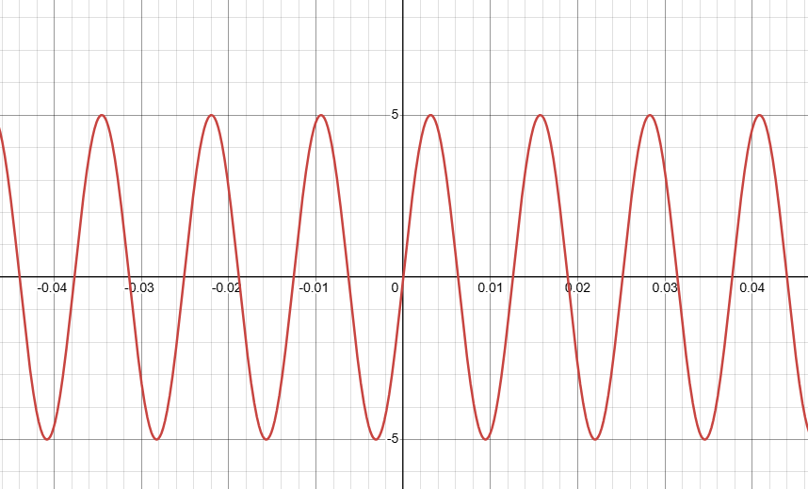

|  |  |
| --- | --- |
|  | |

For 500Hz, we’re using 5ms cycles to see the time period.

*Estimated Graph*

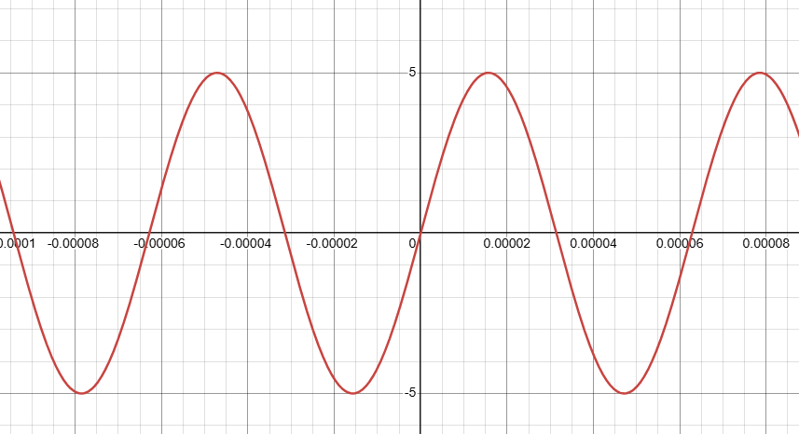

|  |  |
| --- | --- |

At 100kHz, we’re using 5μs to see the intervals.

**4.2.2 Voltage measurements**

| Scope Amplitude: 5.1V DVM Reading: 5.1344Vrms DVM Calculation: 5.1344Vp  Difference Percent: 0.675% | Scope Amplitude: 5.1V DVM Reading: 2.9582Vrms DVM Calculation: 5.124Vp  Difference Percent: 0.471% |
| --- | --- |
| Scope Amplitude: 5.1V DVM Reading: 3.6233Vrms DVM Calculation: 5.1241Vp  Difference Percentage: 0.47% | |

**4.2.3 Scope AC and DC inputs**

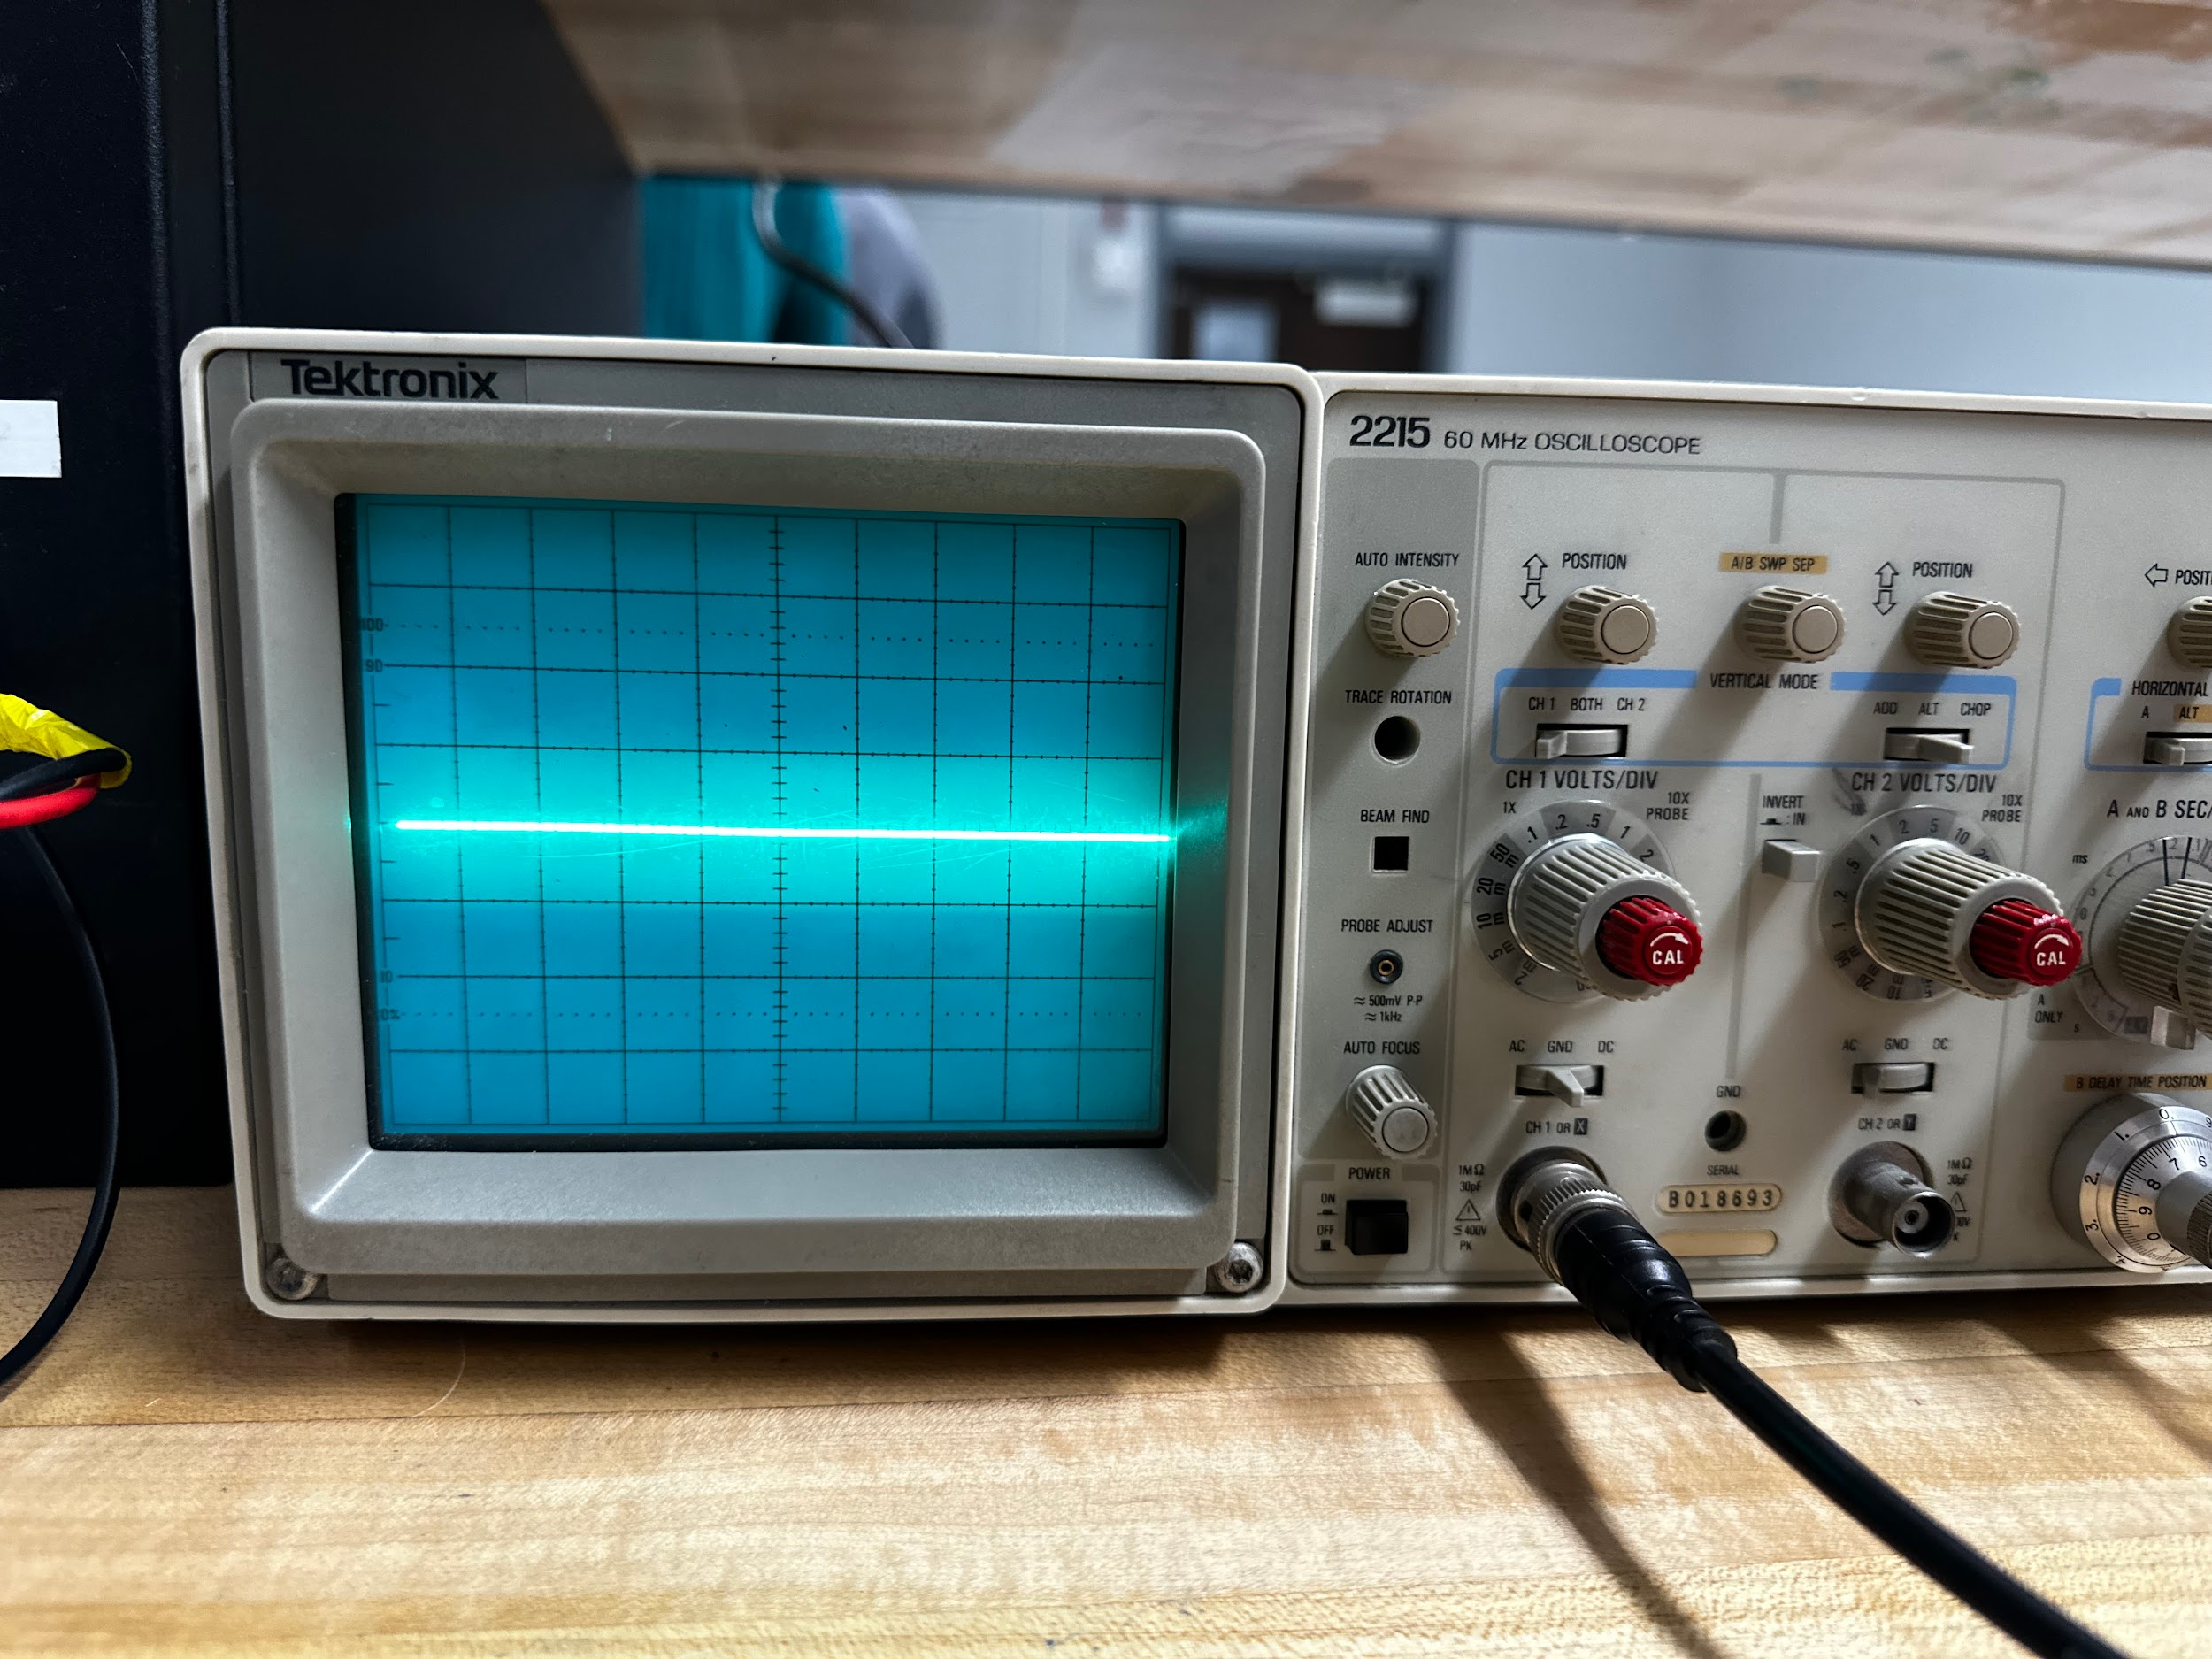

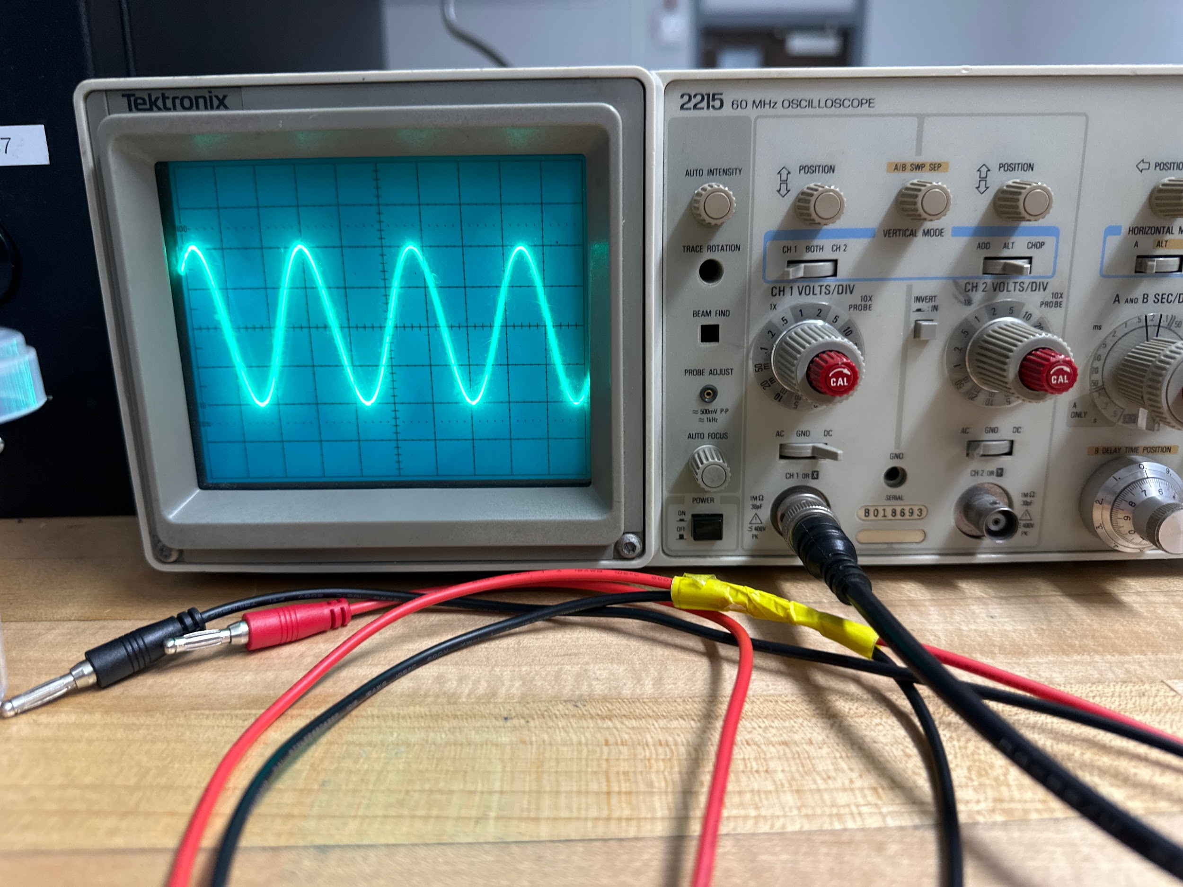

DC without DC Bias

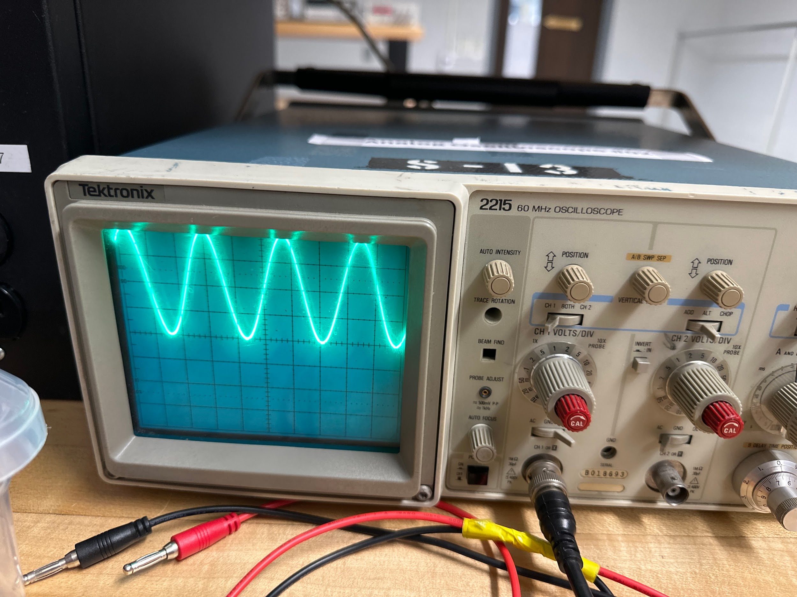

DC Bias

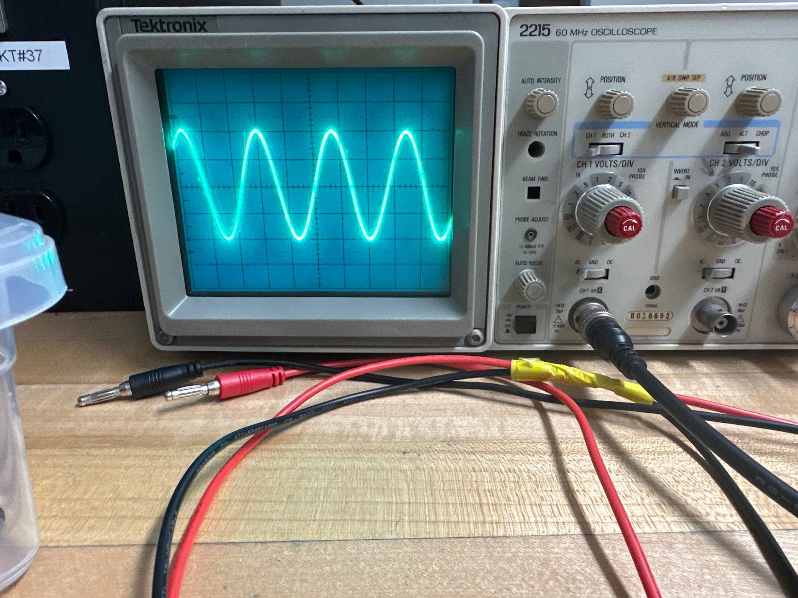

AC Oscilloscope Reading

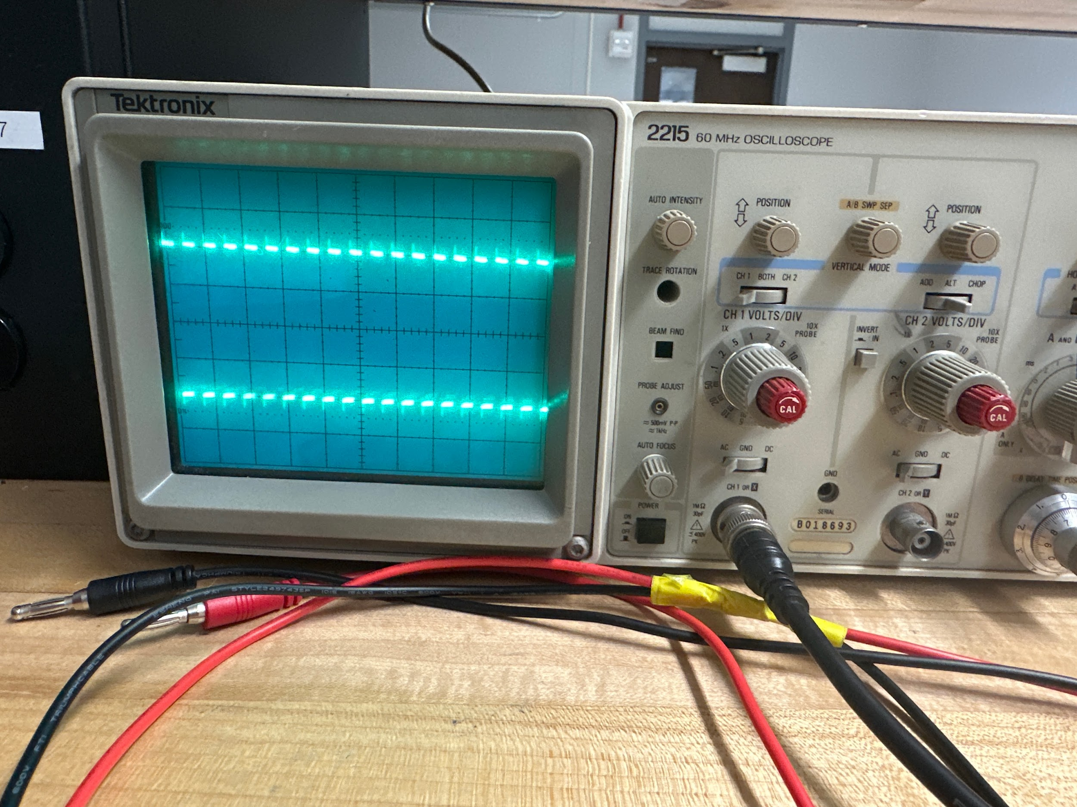

5kHz On AC Input

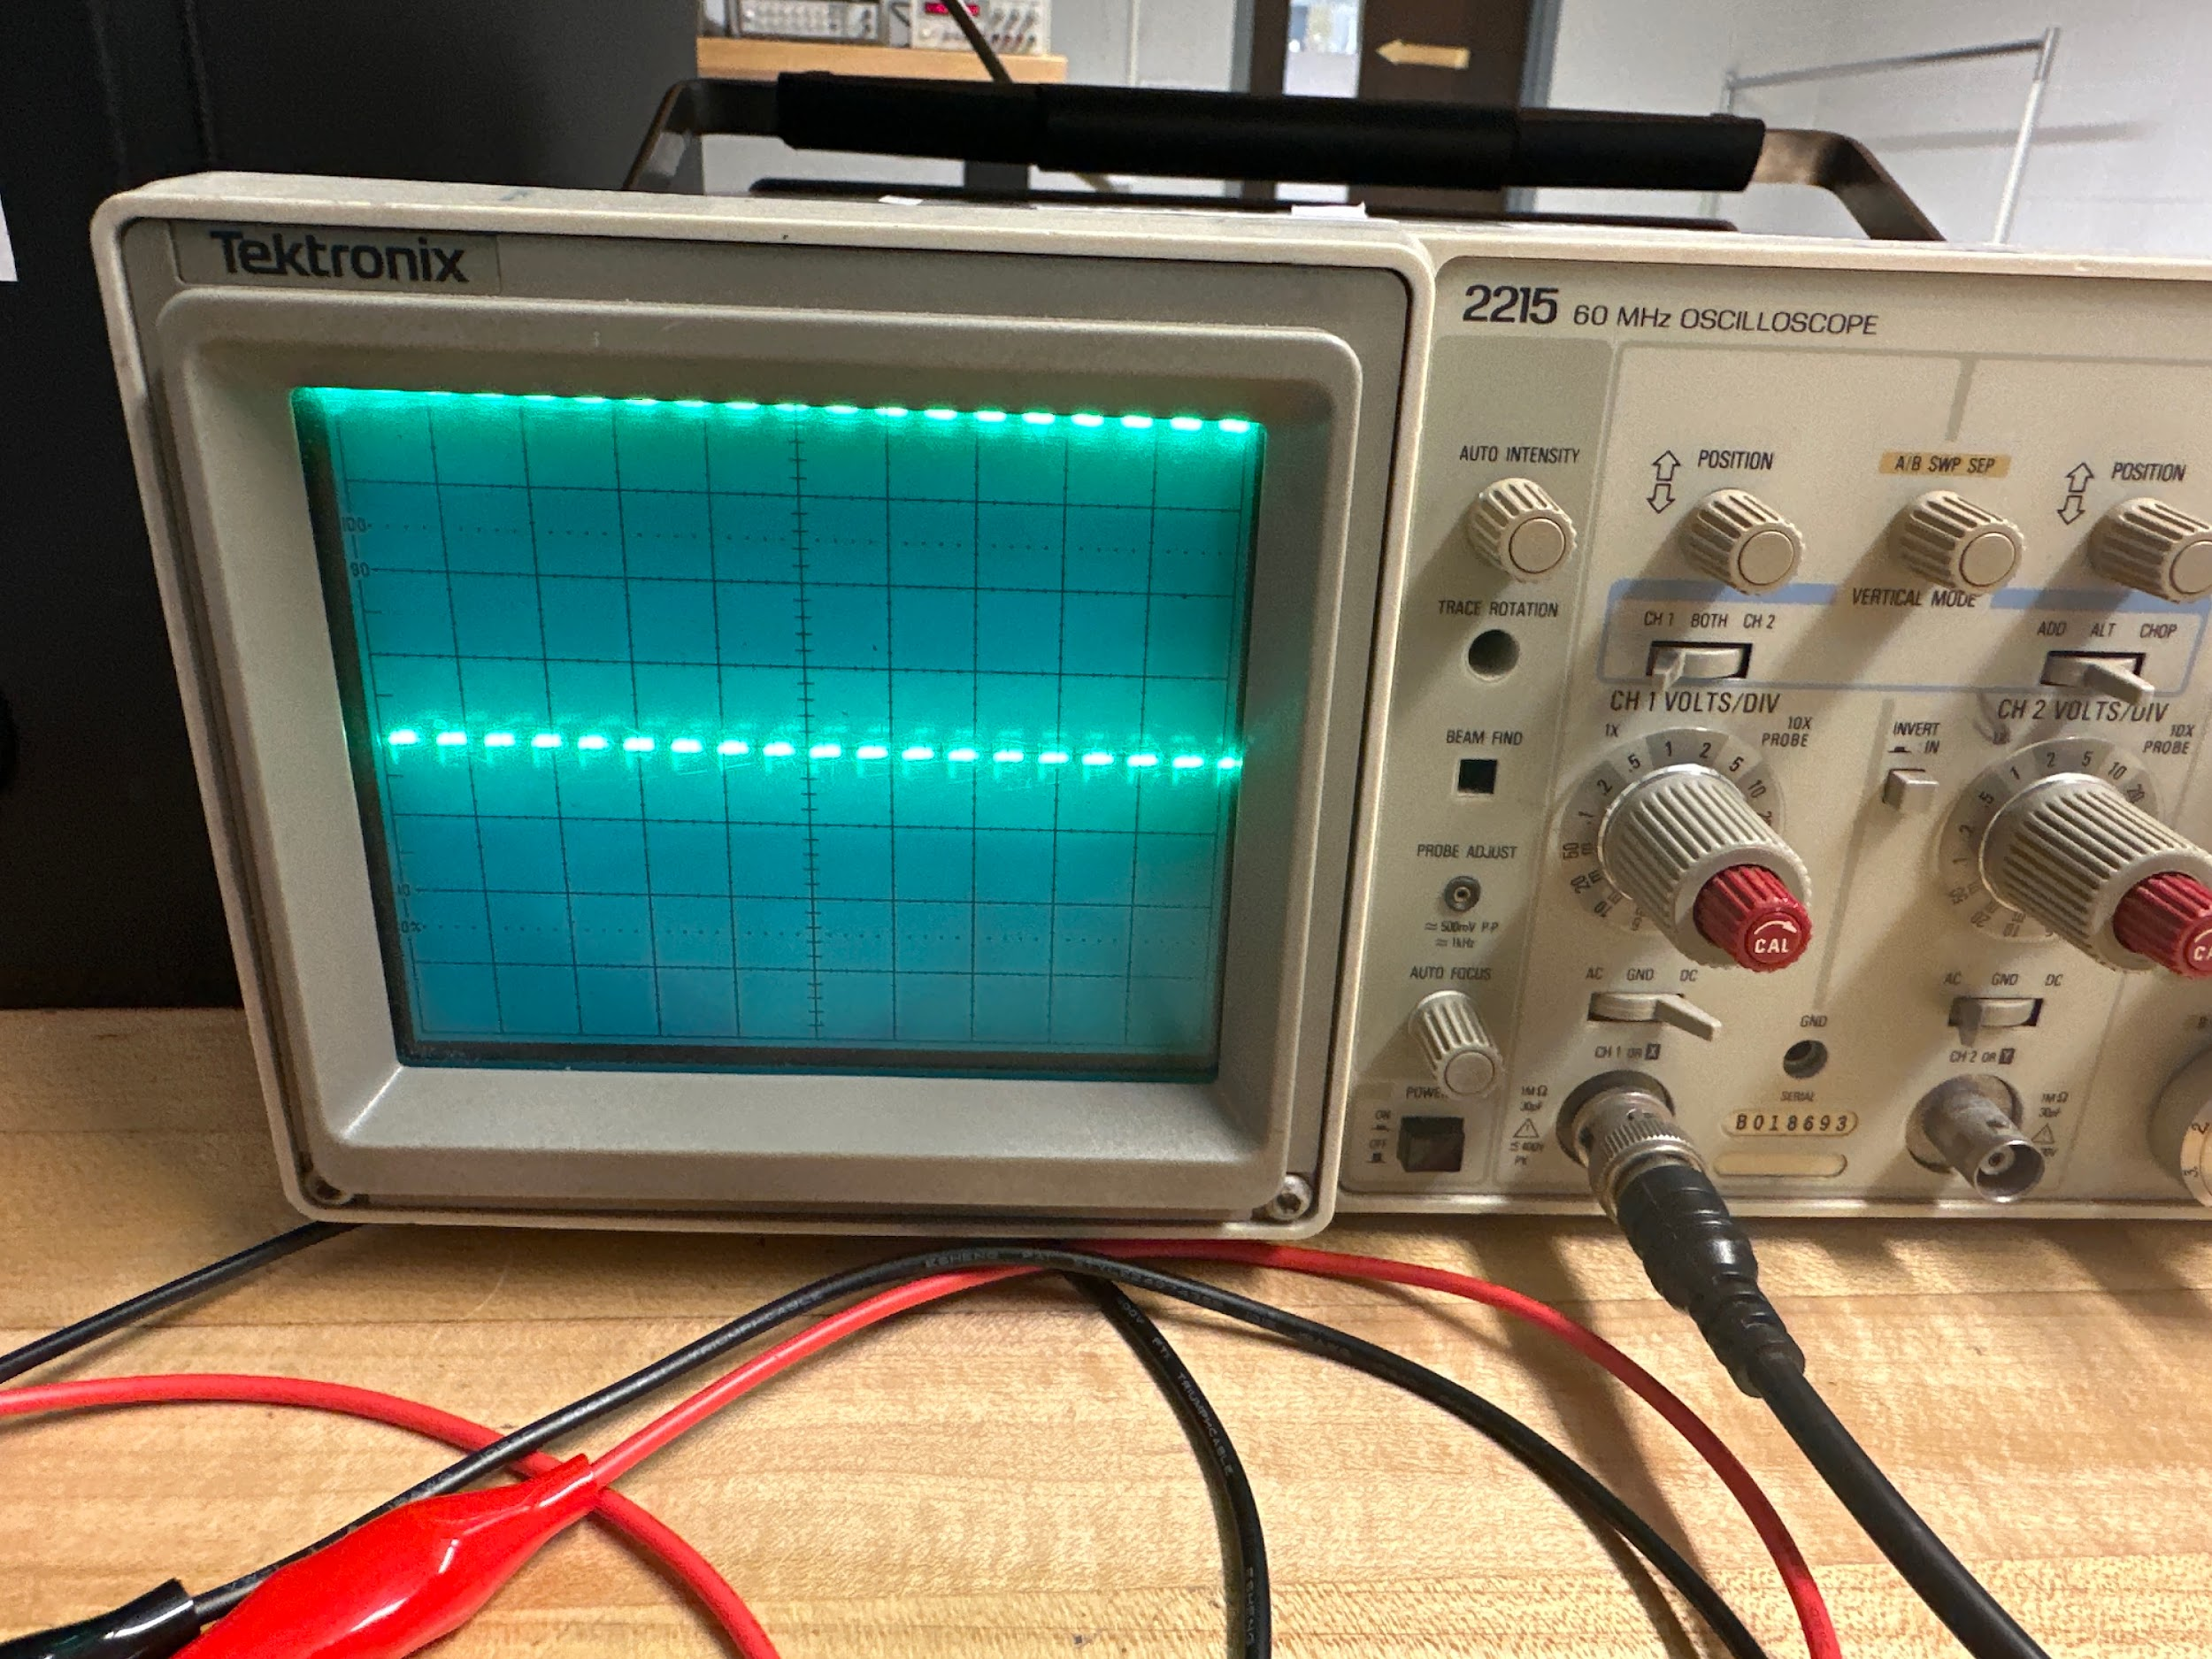

5kHz On DC Input

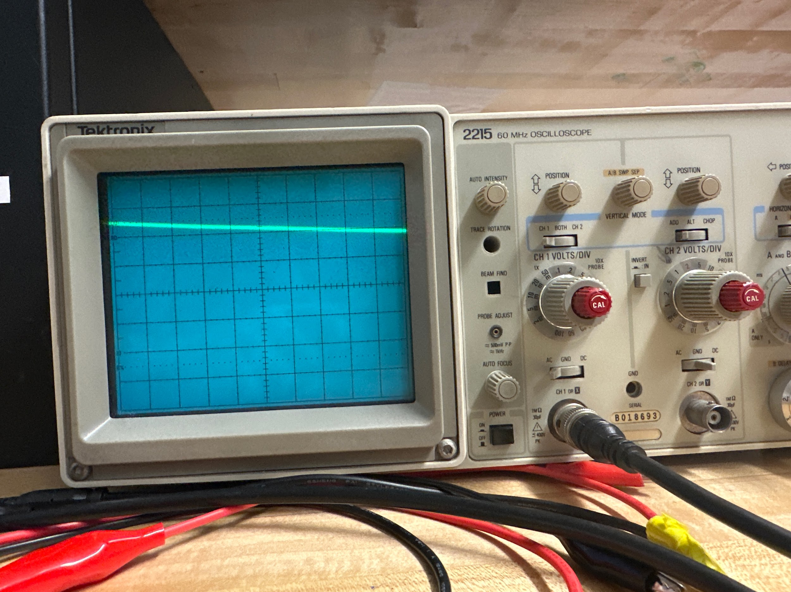

AC Mode 50Hz

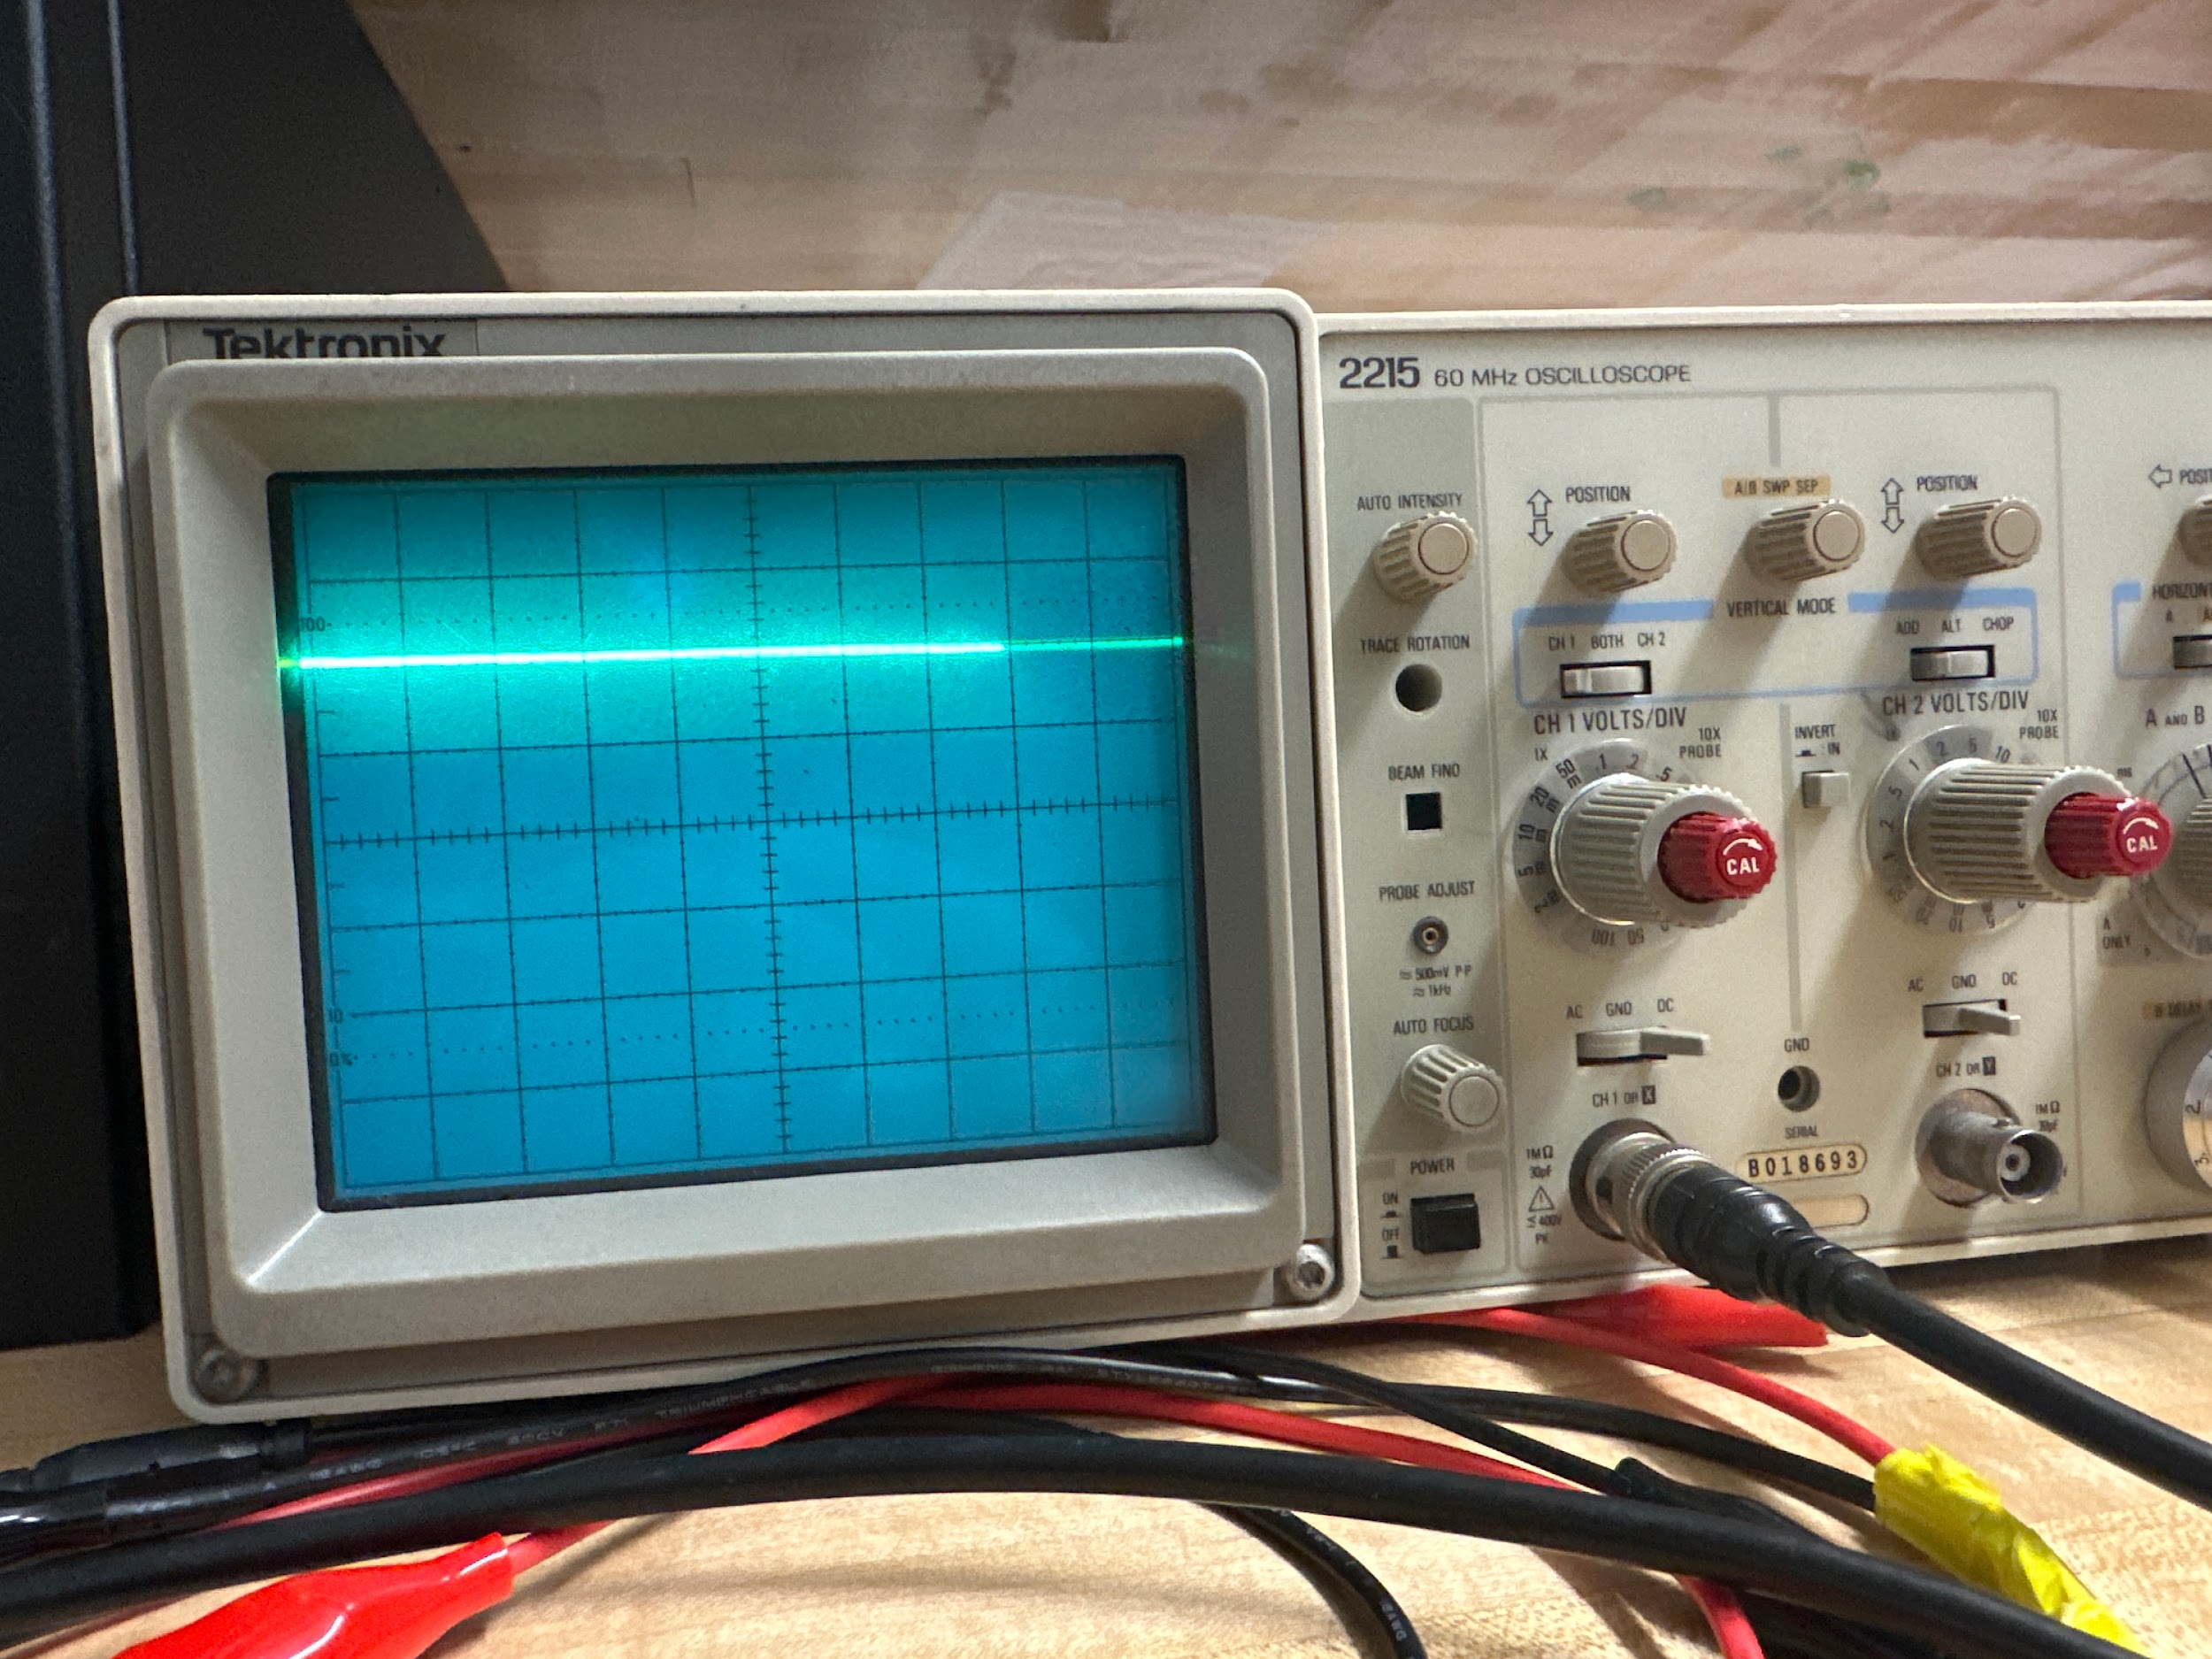

DC Mode 50Hz

**4.2.4 Frequency range of instruments**

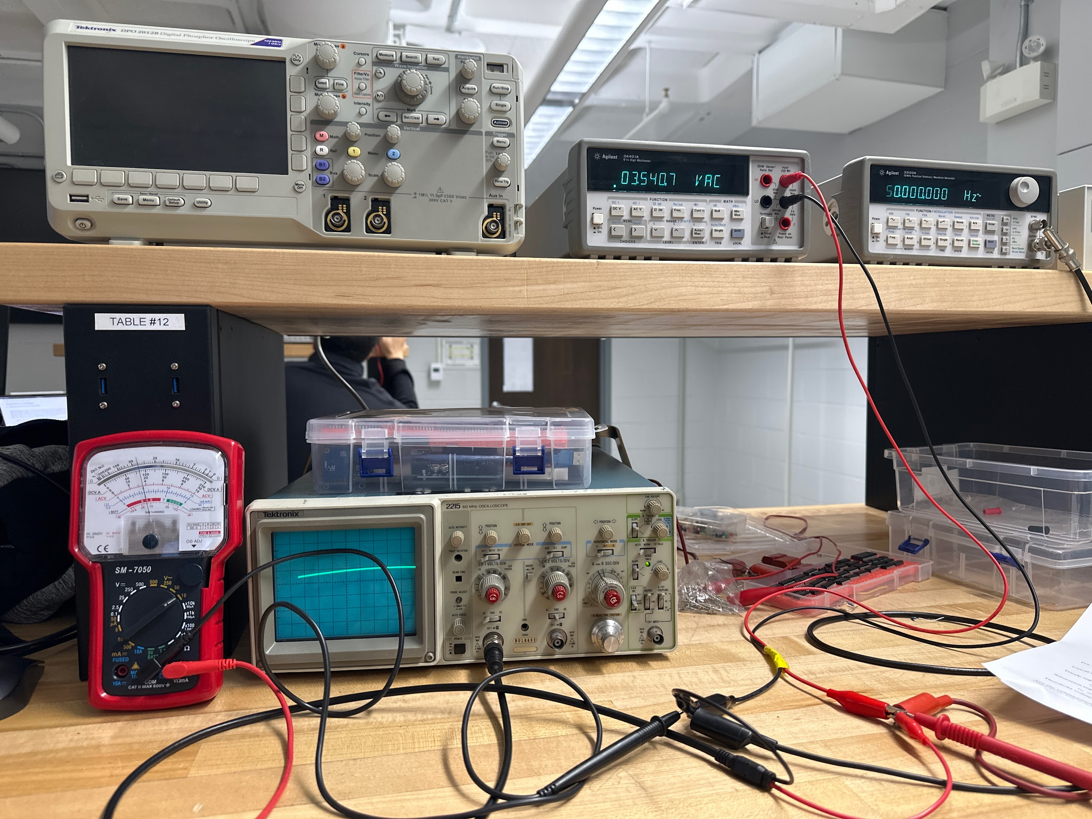

| Frequency | DVM Reading | AVM Reading |
| --- | --- | --- |
| 50 Hz | 3.5409V | 3.65V |
| 500 Hz | 3.5424V | 3.75V |
| 5k Hz | 3.5417V | 3.65V |
| 50K Hz | 3.5224V | 3.60V |
| 500K Hz | 3.2226V | 3.15V |
| 5M Hz | 0.70095V | 0.00V |
| 15M Hz | 0.775 mV | 0.00V |

True Vrms = 3.5355V

At 20 Hz, Vrms = 3.5380 V , %error = ± 0.07 %

AVM Reading = 3.600 V, %error = ± 1.79 %

**4.3 The Digital Oscilloscope**

|  | |
| --- | --- |
| 500kHz    100Hz | |

| Scope Amplitude: 5.0V DVM Reading: 5.0035Vrms DVM Calculation: 5.0035Vp  Difference Percent: 0.07% | Scope Amplitude: 5.0V DVM Reading: 2.8881Vrms DVM Calculation: 5.00235Vp  Difference Percent: 0.0467% |
| --- | --- |
| Scope Amplitude: 5.0V DVM Reading: 3.5409Vrms DVM Calculation: 5.00758Vp  Difference Percentage: 0.1516% | |

**Discussion**

In this lab, we investigated the functionality of electronic instruments such as analog and digital oscilloscopes, a DC power supply, a waveform generator, and digital (DVM) and analog (AVM) voltmeters using hands-on experiments involving voltage and time measurements of sine, triangular, and square waveforms. The oscilloscope measured peak voltage by counting screen divisions as a sine wave spanning 4 divisions at 1 V/division yielded Vp = 2 V while the DVM measured RMS voltage, calculated as Vrms = Vp / √2 for sine, Vp for square, and Vp / √3 for triangular waves, with actual DVM readings showing small 1-2% differences, confirming accuracy. For part 4.1, DVM is certainly more accurate than AVM so it will be used and in regard to part 4.2.2, the values for the square wave and the triangular waves are off when compared to the peak values read from the oscilloscope. The sine value read in the multimeter however is much more accurate, with less than 1% difference. We tested the instruments’ frequency limits and found the DVM reliable up to 100 kHz and the AVM only to 1 kHz which showed the DVM’s superior high-frequency response. We also observed the oscilloscope’s AC mode filtering DC bias distorting low-frequency square waves and the digital oscilloscope’s advantage in providing precise numerical readings, showing the importance of selecting instruments based on signal characteristics.

**Conclusions**

This lab gave us a hands on introduction to the basic electronic instruments, especially the oscilloscope’s role in signal analysis through experiments with DC power supplies, digital and analog voltmeters being DVM and AVM, and both analog and digital oscilloscopes. We learned how to set up the DC power supply for for dual polarity outputs (like +15V and -15V), compare the precision of DVM readings with AVM trends, and master oscilloscope techniques such as adjusting time bases, triggering for stable waveforms, and using interesting digital features like automated measurements and waveform storage. Challenges included stabilizing analog oscilloscope displays and understanding how waveforms affect voltmeter readings, showing us the need for practical judgment in choosing and calibrating tools. By combining theory with practice, this lab gave us essential skills for circuit design, measurement, and troubleshooting, setting a solid foundation for advanced electronics work, including signal processing and embedded systems design, where picking the right instrument and understanding signal behavior are crucial.